|  |  |
| --- | --- |
|  | **IMG_1481.JPG**  **Annual Report 2015**  **Development of Sustainable**  **Renewable Energy Power**  **Generation (SREPGen)**  **Project**  **United Nations Development**  **Programme (UNDP)**  **Bangladesh** |

**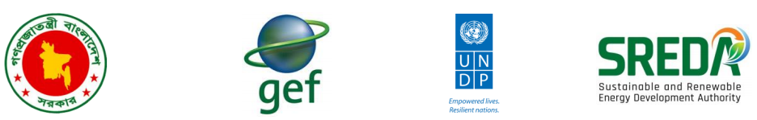**

**Content**

|  |  |
| --- | --- |
| **Background** | **3** |
| **Project Description** | **4** |
| **Project Activities in Timeline** | **5** |
| **Project Components** | **6** |
| **Key Results** | **7** |
| **Progress Towards Outcome** | **8** |
| **Capacity Building** | **9** |
| **Stakeholder Consultation** | **10** |
| **Knowledge Management** | **11** |
| **Communications & Advocacy** | **12** |
| **Innovations** | **13** |
| **Research Studies** | **14** |
| **Diffusion of PVSL into Enclaves** | **15** |
| **Status of Financial Progress** | **16** |
| **Looking Forward** | **17** |
| **Conclusion** | **17** |

**national project director’s Message**

It is with great pleasure that “Development of Sustainable Renewable Energy Power Generation (SREPGen)” project presents a report on the activities and achievements in 2015. This Annual Report is a collective effort involving government officials from the various ministries and local administration, UNDP, civil society representatives and our development partners. Though the project document signed in November 2013, but for clearing all formalities actually project started on January 2015. The official launching of the project with inception workshop was held in March, 2015 where some activities had been redesigned with the consultation of workshop participants. The year 2015 was vitally important for the project as a conception phase aimed at providing assistance to SREDA to initiate development and operationalize an RE investment facilitation center. The achievement of this year highlights capacity building initiative for SREDA personnel to develop a pool of talent people, development of promotional materials, new office set up, launching SREDA website and stakeholder consultation meeting on scaling up RE projects. I would like to thanks to UNDP’s SREPGen team for their continuous support on the implementation of SREDA’s envisions to build a energy conscious nation through sustained use of renewable energy. I believe that the upcoming year will be a great opportunity for the program people to show their best performance in implementing the targeted activities successfully.

**Md. Anwarul Islam Sikder, ndc**

**Message from Project Manager**

SREPGen project started it’s journey with an objective to reduce the annual growth rate of GHG emissions by exploiting Bangladesh’s renewable energy resources for electricity generation. The basic approach is to promote renewable energy in Bangladesh through the recently established Sustainable and Renewable Energy Development Authority (SREDA).We believe that bymaterializingSREDAinitsfullpotentials,Bangladeshhasthepotentialtoreduceitsfossil fuel dependence, to improve its energy security and to reduce green house gas (GHG) emission. During the reporting period we establish a new office set up for SREDA, provide technical assistances needed to build the capacity of SREDA personnel, develop website and promotional video for SREDA, set up of PMU, form project board committee and conduct PSC and PIC meeting with relevant government officials. There were three important workshop on solar irrigation, waste to energy and solar roof top in this year and a inception meeting where restructuring of project activities and budget was done. Another accomplishment of this year was the distribution of solar lantern into former enclaves area in Bangladesh.

All of our work would not have been possible without the support of SREDA officials, Government representatives and our development partners. There were some barriers in our activity progress during the reporting year, yet we tried to provide our best effort in achieving our planned targets. The upcoming years for us will be crucial in the sense that we have to do a lot of work within the timeframe and more focused on the distribution of big amount of Solar Lanterns to low income households in the country and starting the feasibility study on different RE initiatives. Finally, I would like to thanks to my team members for publishing the Annual Report’2015 with their great effort and innovative ideas.

**Md. Monwar Hasan Khan**

**Background**

Bangladesh, world’s largest delta (147,570km2 of land), accommodates an estimated of 156 million population, 70% of which are living in rural areas, and relying on agrarian economy. Some 10.2 million rural households have little or no access to electricity or to clean energy sources. Even those with access to electricity experience supply disruptions due to supply-demand gap. Therefore, the Government of Bangladesh (GoB) considers the energy sector as a key catalyst to maintain a sustainable Gross Domestic Product (GDP) growth of 7%, and above up to 2020 and beyond.

To deal with the mounting energy demands, GoB has established a national nodal institution—Sustainable and Renewable Energy Development Authority (SREDA)—in 2012 for coordinating as well as monitoring the entire spectrum of green and clean energy technologies. SREDA is dedicated to promote and scale-up Renewable Energy (RE) investments, plans, programs, and measures; and the demand-side Energy Efficiency and Conservation (EE&C) in Bangladesh. By materializing SREDA in its full potentials, Bangladesh has the potential to scale-up the renewable energy initiatives while accelerating energy efficiency, and conservation, in order to reduce the annual growth rate of GHG emissions from the fossil fuel-based power generation.

The United Nations Development Programme (UNDP) in Bangladesh, is working closely with the Government, and its development partners to ensure energy security for the poor and disadvantaged people, and to contribute to GoB's national development, as well as the global efforts of reducing GHG.

Towards this goal, UNDP’s 'Development of Sustainable Renewable Energy Power Generation (SREPGen) Project' aims to strengthen national capacities to mainstream environment and energy concerns into national development plans and implementation systems.

**Do you already have solar panels on your home?**

**□ Yes □ No**

*Even if you can’t put solar panels on your roof right now, you can help the planet by encouraging your family and friends that can!*

**Project Description**

The objective of the SREPGen Project is to reduce the annual growth rate of GHG emissions from the fossil fuel-based power generation by exploiting Bangladesh’s renewable energy resources for electricity generation. The basic approach of the Project will be to promote renewable energy in Bangladesh through the recently established Sustainable and Renewable Energy Development Authority (SREDA).

For Bangladesh, to achieve a greater share of renewable energy (RE) in its energy mix, the Project will support activities that will:

1. Transform SREDA into a strong RE project facilitation center to bring confidence to private RE investors and increase the number of approved RE projects;
2. Increase the capacities of appropriate government agencies to generate, process, obtain and disseminate reliable RE resource information for use by potential project developers and investors;
3. Increase the affordability of photo-voltaic solar lanterns (PVSLs) for low income households by supporting pilot PVSL diffusion activities; and
4. Increase the share of RE in Bangladesh’s power mix through facilitating the financing, implementation and operation of pilot (RE) energy projects.

**Project Snapshot: Sustainable Renewable Energy Power Generation (SREPGen) Project**

|  |  |  |  |  |
| --- | --- | --- | --- | --- |
| **Start Date:** | January 2014 | | | |
| **End Date (estimated):** | December 2018 | | | |
| **Geographic Coverage:** | All over Bangladesh | | | |
| **Focus Area:** | Energy | | | |
| **MDG Focus:**  **SDG Focus:** | Ensure Environmental Sustainability (7)  Affordable and Clean Energy (SDG 7) | | | |
| **Executing Entity/Implementing Partner:** | Power Division of the Ministry of Power Energy and Mineral Resources (MoPEMR) | | | |
| **Implementing Entity/Responsible Partners:** | Sustainable and Renewable Energy Development Authority (SREDA) | | | |
| **Total allocated resources:** | US$ | 53,677,272 |  | |
|  | US$ | 4,077,272 | 7.6% | Global Environment Facility (GEF) |
|  | US$ | 5,000,000 | 9.3% | UNDP |
|  | US$ | 21,150,000 | 39.4% | Government of Bangladesh |
|  | US$ | 250,000 | 0.5% | GIZ |
|  | US$ | 200,000 | 0.4% | Clean Energy Alternatives |
|  | US$ | 20,000,000 | 37.3% | Tianjin Machinery I&E Co. |
|  | US$ | 3,000,000 | 5.6% | Private Sector |
| **Project Links:** | http://bit.ly/1KnlfAL | | | |

**Project Activities in Timeline**

**The SREPGen Project is started in January 2014 with an estimated end date in December 2018. Since its inception, the various project activities are highlighted in the following progressive timeline.**

**Dec 2018**

**SREPGen Project Closure**

**2nd PSC meeting** (13/08/15)

**Workshop on waste to energy(1**/10/15)

**1st PIC meeting**(24/08/15)

**Two video documentary**

**Formation of PIC & Technical Committee (TC)**

**Start of PVSL distribution in former enclaves area** (05/10/15)

**Workshop on solar irrigation** (03/09/15)

**Developed SREDA website content (Bangla & English)**

**Workshop on solar rooftop** (31/12/15)

**1st PSC meeting**(26/04/15)

**Inception workshop** (05/03/15)

**SREPGen Project Started**

**Project Implementation Report (PIR) submission to GEF**

**Annual Work Plan (AWP)revision** (05/11/15)

**Midterm evaluation by UNDP** (05/11/15)

**Monitoring and Evaluation (M&E) plan revision** (05/11/15)

**2nd PIC meeting**(05/11/15)

**Jan 2016**

**Jul**

**Jun**

**May**

**Apr**

**Mar**

**Dec**

**Nov**

**Oct**

**Sep**

**Aug**

**Feb**

**Jan 2015**

**Jan 2014**

**Result Oriented Annual Report (ROAR) and Quality Assurance Report (QAR) submission to UNDP**

**Project Components**

**Output/Component 1: RE policy and regulatory support program:**

This component addresses the barrier concerning the lack of appropriate policy and regulatory framework for RE power investment. The expected outcome from the outputs that will be delivered by the activities that will be carried out under this component is the evolution of SREDA into a facilitation center that supports private sector RE investment development, enables regulators to determine fair flexible tariff structures, brings confidence to private RE investors, and increases the number of approved RE projects.The following outputs will contribute to the achievement of this outcome:

**Output/Component 2: Resource Assessment Support Program**

This component is intended to address the barriers associated with the lack of reliable RE resource data that can be used by prospective RE project developers and investors. The expected outcome from the deliverables of the activities that will be conducted under this component is increased capacity of SREDA and other relevant government agencies in generating, processing, obtaining, and disseminating reliable RE resource information for use by GoB and potential project developers and investors.

**Output/Component 3: Diffusion of photovoltaic-powered solar LED lanterns (PVSLs) to low-income households**

This 'pro-poor' component is designed to scale-up ongoing efforts led by the GIZ-SED supported SOLIB programme to overcome an inability of marginal low income households to pay for high quality PVSLs. Activities on this component are more focused on issues relating to PVSL affordability, protecting low income consumers from poor quality products, boosting and sustaining their confidence in the quality and durability of PVSLs in the program, and sustaining the growth of PVSLs to the estimated 10.2 million low income households in Bangladesh whose income is insufficient to afford an SHS. The expected outcome is increased affordability of PVSLs to low income households.

**Output/ Component 4: Renewable energy investment scale-up:**

This component will address the barriers of a lack of capacity within the financial sector to develop financing packages for RE projects and poor perceptions of RE projects in Bangladesh. It will do so by supporting SREDA efforts to assist RE project developments already identified as priority programs by the GoB. The expected outcome is the increased share of renewable energy in Bangladesh’s power generation mix resulting from a catalyzed RE investment environment

**Key Results**

**During the 2015 reporting period:**

* **Total 3.45% renewable energy produced against the GoB’s targets of 5% or 800 MW by 2015.**
* **Present solar PV electricity generation accounts for a total 166 MW from Off grid and 7 MW from on grid including solar home system, solar irrigation, roof top and mini grid.**

**Results and outputs are further illustrated under the following themes:**

**Progress Towards Outcome**

**Capacity Building**

**Stakeholder Consultation**

**Knowledge Management**

**Communications & Advocacy**

**Innovations**

**Research Studies**

**Services for Hard-to-Reach Population**

###### **Renewable Energy Share reaches 3.45%**

###### **Aiming to reduce GHG emissions, the government formed SREDA for promoting sustainable energy and generating 2000 MW electricity in 2021, and 4000 MW in 2030. The present renewable energy & energy efficiency scenario of Bangladesh is 423 MW and RE share reached 3.45 percent.**

| **Progress Towards Outcome** | | | **Target Level** | | |
| --- | --- | --- | --- | --- | --- |
| **Description** | | **Description of Indicator** | **Baseline - 2014** | **Project end Dec'18** | **as of**  **31 Dec'15** |
| **Objective** | Reduction in the annual growth rate of GHG emissions from fossil fuel-fired power generation through the exploitation of Bangladesh's renewable energy resources for power generation | - Cumulative direct post-project CO2 emission reductions resulting from the RE technical assistance and investments by end-of-project (EOP), Mtons CO2. | 0 | 1.64 | 0 |
| - % share of RE in the power generation mix of Bangladesh | 1 | 6 | 3.45 |
| **Outcome 1** | SREDA evolves into a facilitation center to support private sector RE investments, enable regulators to determine fair flexible tariff structures, bring confidence to private RE investors, & increase the # of approved RE projects | - Number of on-grid Renewable Energy projects approved by Sustainable Renewable Energy Development Authority(SREDA) as a result of conducting different studies and developing operational rules | 0 | 4 | 0 |
| - # of RE development project proponents that were assisted by SREDA staff in the technical design and approval of their projects | 0 | 6 | 0 |
| **Outcome 2** | Increased capacities of relevant government agencies to generate, process, obtain and disseminate reliable RE resource information for use by GoB and potential project developers and investors | - Number of implemented wind energy project approved by SREDA as a result of resource assessment support program | 0 | 1 | 0 |
| - Number of RE resource assessments and data gathering, carried out by private sector | 1 | 7 | 0 |
| - Number of biomass-based power generation projects that were designed based on the biomass resource assessment data | 0 | 4 | 0 |
| **Outcome 3** | Increased affordability of photovoltaic solar LED lanterns (PVSLs) for low income households | - # of government-certified PVSL models that meet Int. standards for functionality & durability that are imported into the country | 1 | 5 | 0 |
| - Number of low income households that are able to afford monthly payments from established and operational financial mechanisms for the purchase and use of PVSLs | 0 | 133,000 | 139 enclave’s h/h |
| - # of PVSL supply &delivery chains that also provide product support & credit collection by Year 2 | 0 | 3 | 1 |
| - Number of rural household using PVS Lanterns in the intervention area | 0 | 133,000 | 139 |
| **Outcome 4** | Renewable energy accounts for an increased share of Bangladesh's power generation mix | - Number of RE projects that are financed through RE funds where SREDA has had involvement in operationalization | 0 | 2 | 0 |
| - Megawatts of on-grid renewable energy generated by the end of the project | 1.5 MW ex. Hydro | 1392 MW | 1.9 (on grid SPV &wind |
| - Megawatts of off-grid renewable energy generated by the end of the project | 162 MW | 395 MW | 184 MW (off grid) |
| - % increase of RE in Bangladesh’s power generation mix by EOP | 3.4% | 9.2% | 3.45% |
| - MW capacity of RE generation projects (on & off-grid) in planning & design stages by EOP | 500 MW | 1790 MW | 411 |

**Capacity Building**

**A majority of the SREDA's staffs are newly recruited, and several others came from different government organizations on deputation for 1/2 years. Therefore, on job trainings are especially important. A well trained and more cohesive staff instinctively feel they are a part of the organization, and results with optimal utilization of resources in an organization.**

**Over the 2015 reporting year, SREPGen has organized one training program, one lesson learned workshop and one international study tour.**

|  |  |
| --- | --- |
| **Type:** | One (1) day lesson learned workshop (3rd September 2015) |
| **Title:** | Risk and Issue log management and monitoring in Atlas & Maintaining UNDP's Transparency standards |
| **Objective:** | Learning to update AIMS, Risk & Issue log, transparency document |
| **Participants:** | SREPGen project staffs |
| **Organizer:** | Results and Resource Management Cluster (RRMC) of UNDP |
| **Facilitators:** | Karolien Casaer, Shawakwat, Munir Hossain, Rezaul Haque, Saroar Hossain |

|  |
| --- |
| **Activity 1** |

|  |
| --- |
| **Activity 1** |

|  |  |
| --- | --- |
| **Type:** | Five (5) days Training Program  (29th September to 4th October’2015) |
| **Title:** | Renewable Energy and Its Application: Solar, Wind, Biomass |
| **Objective:** | Developing knowledge base on RE technology |
| **Participants:** | 15 newly recruited SREDA staffs |
| **Organizer:** | Institute of Energy, Dhaka University |

|  |
| --- |
| **Activity 1** |

|  |  |
| --- | --- |
| **Type:** | Three (3) days International study tour in Delhi |
| **Title:** | Project Management Training |
| **Objective:** | Learning to update AIMS, Risk & Issue log, transparency document |
| **Participants:** | Project Manager of SREPGen |
| **Organizer:** | GEF-UNDP |
|  |  |

g

|  |  |
| --- | --- |
| **Type:** | One day workshop(March 5, 2015) |
| **Title:** | Inception workshop on SREPGen |
| **Objective:** | Stakeholders' involvement and cooperation in project planning |
| **Participants:** | 50 participants (approx.) from GOs, INGOs and private sector |
| **Organizer:** | SREPGen in association with UNDP and SREDA |
| **Key Guests:** | State Minister of MPEMR; Secretary of the Power Division; Country Director of the UNDP |
| **Highlights:** | Three working group discussions |

|  |  |
| --- | --- |
| **Type:** | One Day Workshop (27th December) |
| **Title:** | Solar Rooftop-its viable option for Bangladesh |
| **Objective:** | Finding out existing challenges, and developinginnovative solutions |
| **Participants:** | Approximately 180 GO, NGO and private sector officials |
| **Organizer:** | SREDA in association with UNDP |
| **Key Guests:** | Minister of MOHPW, Prime Minister's advisor; State Minister of MPEMR; Secretary of Power Division & Secretary of MOHPW |
| **Presentation:** | followed by Q&A session |

**Stakeholder Consultation**

|  |
| --- |
| **Activity 4** |

|  |
| --- |
| **Activity 4** |

|  |
| --- |
| **Activity 1** |

Bangladesh is the pioneer in introducing solar home systems in rural areas. . So, for now,it has to deviceaninnovative solution to customize the solar systems for urban areas.

Solar powered irrigation system can be a viable and environmental friendly option for sustainable agriculture.

**Over the 2015 reporting year, stakeholders' views (also available in SREDA website) were sought through three (3) consultative workshops, which helped to make transparent, well-targeted, coherent, and informed policy, that are based on evidence, the experience and the views of those affected by the policies and involved in their implementation.**

|  |  |
| --- | --- |
| **Type:** | One day Stakeholder Workshop (1 October) |
| **Title:** | Waste to Energy-Opportunity and Challenges in Bangladesh |
| **Objective:** | Sensitization on energy generation from municipal waste |
| **Participants:** | 65 from GOs, NGOs and private sector |
| **Organizer:** | SREDA in association with UNDP |
| **KeyGuests:** | State Minister of Power, Energy & Mineral Resources;  Secretary of Power Division; Country Director, UNDP Bangladesh |
| **Presentation:** | Policy Initiatives on Waste to Energy, followed by Q&A session |

|  |  |
| --- | --- |
| **Type:** | One day workshop(March 5, 2015) |
| **Title:** | Scaling up of Solar Irrigation in Bangladesh |
| **Objective:** | Share the progress, challenges, experiences and future plan on the present solar irrigation expansion activities |
| **Participants:** | 20 participants (approx.) from GOs, INGOs and private sector |
| **Organizer:** | SREPGen in association with UNDP and SREDA |
| **Key Guests:** | Dr. Tawfiq-e-Elahi Chowdhury , Bir Bikrom, Hon’ble Advisor to the Prime Minister, Power, Energy and Mineral Resources Affairs |
| **Highlights:** | Oversee the progresses that are made by different implementing agencies while working on solar pump scaling up activities |

|  |
| --- |
| **Activity 4** |

Workshop Picture:

|  |  |  |
| --- | --- | --- |
| C:\Users\USER\Desktop\Solar Irrigation Report\picture\workshop for solar irigation picture\IMG_4659.JPG  A roundtable discussion on solar irrigation workshop | C:\Users\Dell\Desktop\Project Picture\BNN_175.jpg  Honorable state minister addressing his valuable speech in Waste to Energy workshop | DSCN0764.JPG  Guests in the Inception workshop of the project |
| C:\Users\Dell\Desktop\Project Picture\Certificate distribution in DU.JPG  Certificate distribution | C:\Users\Dell\Desktop\Project Picture\Seminar on Solar Roof Top-it's Viable Option for Bangladesh (27-12-2015)\IMG_8316.JPG  Honorable Guests attended in the Solar Rooftop Workshop | C:\Users\Dell\Desktop\Project Picture\Seminar on Solar Roof Top-it's Viable Option for Bangladesh (27-12-2015)\IMG_8241.JPG  A small meeting held before starting the solar rooftop workshop |

**Knowledge Management**

|  |
| --- |
| **Activity 2** |

|  |
| --- |
| **Knowledge Management (KM) is an integral part to meet any project objectives, and technology is an important enabler to the success of KM. Therefore, for the widespread dissemination of information and database related to sustainable and renewable energy development in Bangladesh, SREPGen has launched an Internet-based collaborative knowledge sharing platform (i.e. website and on-line social media), which is being updated routinely.**  **The host of this website (www.sreda.gov.bd) is SREDA, GoB's nodal authority for sustainable and renewable energy. And the aim is to make SREDA evolve as an interdisciplinary knowledge platform that builds understanding and concern for sustainable and renewable energy, and the competence to act on such knowledge. Since it was first launched, there were approximately 68,293 visitors in this website, and on an average 200 visits per day and 4000 visits per week.** |

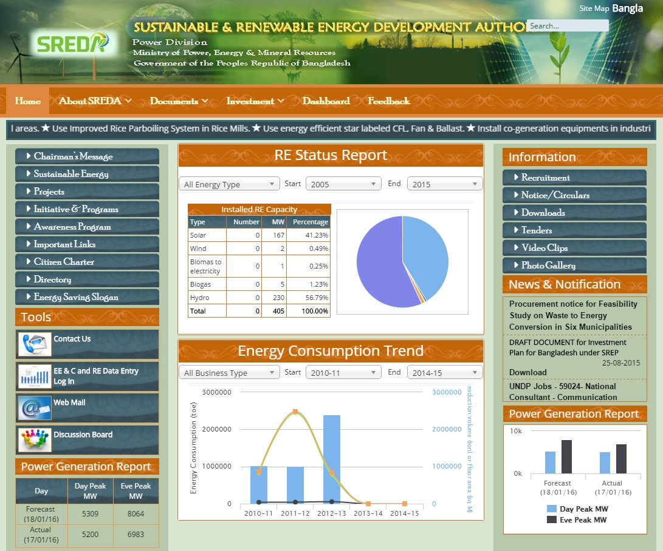

**Communications & Advocacy**

**Stakeholder Consultation**

|  |
| --- |
| **Activity1** |

|  |
| --- |
| **For the 2015 reporting year, two (2) promotional video clips were produced to showcase various initiatives of renewable energy production and energy efficiency in Bangladesh, in line with SREDA's activities. These videos were disseminated via social media (e.g. YouTube, Website, Email links) among the stakeholders, partners, and the general people could also access them freely via Internet. They are also shown regularly in various workshops, seminars, and meetings as part of promotion activities.** |

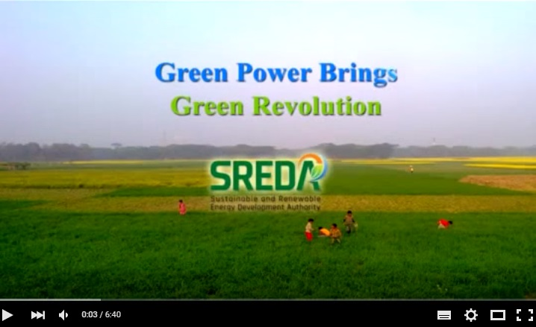

|  |  |
| --- | --- |
| **Duration:** | 6.41 minutes |
| **Topic:** | Multiple usage of solar energy systems such as solar irrigation, solar home, use of mini grid as well as other solar system |
| **Web link:** | https://www.youtube.com/watch?v=zk9Rpv3Pl4s |

|  |  |
| --- | --- |
| **Duration:** | 5.42 minutes |
| **Topic:** | Promoting renewable energy in line with SREDA's activities |
| **Web link:** | https://www.youtube.com/watch?v=YHo2mKQwTG8 |

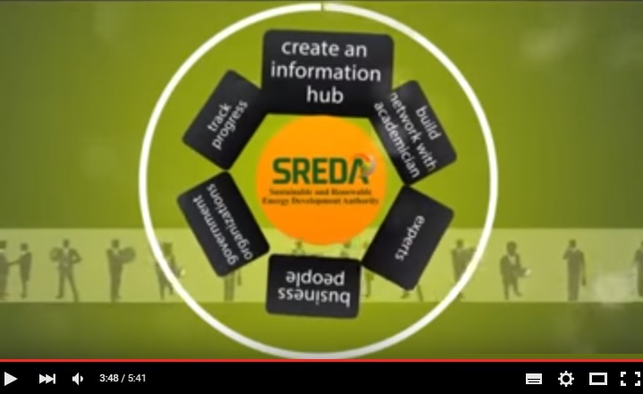

**Innovations**

|  |
| --- |
| **Activity 4** |

|  |
| --- |
| **Bangladesh is crisscrossed by some 800 rivers and their tributaries, constituting a waterway of total length of 24,140 Km (approx.). So, waterways play a significant role in inland transportation. This apart, a large number of boats are used for fishing in the rivers as well as in the Bay of Bengal. Most of these boats are driven by small sized diesel engines, which are not efficient and cost effective. These are not environment friendly either, as they emit black smoke - causing air pollution, and the leakages of engine oil pollutes the free flowing water.**  **With the falling price of solar photovoltaic (PV), conversion of the boats from diesel to PV based electric motors looks quite potential, as PV-driven electric motors are pollution free, cost effective than that of diesel engines.**  **For the 2015 reporting year, SREPGen has initiated the process of a feasibility study to assess the solar boat potential in Bangladesh, and to design & develop five (5) categories of solar boats, which are feasible in the local contexts. For this purpose, the procurement process of a consulting firm has already been completed.** |

|  |  |
| --- | --- |
| **Status:** | Ongoing |
| **Study title:** | Feasibility study, and Piloting of Solar Boats |
| **Service provider:** | Consultancy Firm (external) |
| **Start date:** | 1 February 2016 |
| **End date:** | 30 November 2016 |

|  |
| --- |
|  |

|  |
| --- |
| **One of the potential sources of renewable energy in Bangladesh is waste to energy. There are 333 municipalities (A category 124, B category 116 and C category 82) in Bangladesh. Waste generation rate in city corporation varies from 0.25 to 0.56 kg per person per day where average 0.25 kg waste generate per capita per day in Pourashavas (municipalities). All these municipalities are responsible to manage the waste produced in their premises. More than 70% of wastage are organic, high moisture content, low caloric value and lack of space for disposal of solid waste is challenges for municipalities. Based on the daily production of waste, there is possibility to generate electricity by treating these wastes with appropriate technology. For setting up electricity generating unit from municipality waste, it needs detailed feasibility study and piloting. For this purpose, SREPGen project is seeking a talented professional to do a feasibility study in six municipalities for waste to power generation and have a detailed specification and design of pilot power plant.** |

**Research Studies**

|  |
| --- |
| **Activity 4** |

|  |
| --- |
| http://www.holmeswelding.com/Images/LM-80-waste-body-working-dumpingLG.jpg |

|  |  |
| --- | --- |
| **Status:** | Ongoing |
| **Study title:** | Conducting a Feasibility on Waste to Energy Conversation in Six Municipalities in Bangladesh |
| **Service provider:** | External Consulting Firm |
| **Start date:** | 1 October 2015 |
| **End date:** | 30 March 2016 |

|  |  |
| --- | --- |
|  |  |
| **Item:** | Solar Lantern |
| **Item Cost:** | BDT 2150 - 3150 |
| **Subsidy:** | $75 (buys down grant per solar lantern) |
| **Target:** | 7642 enclave household |
| **Sold:** | 157 Lanterns |
| **Distributor:** | IDCOL through its local partners |

**Services for Hard-to-Reach Population**

***'Solar Lantern gave us a new hope for life' - inhabitants of an enclave***

**Nasiruddin, Abdul, Shahiruddin, Monirul live with their families in an enclave area called DahalaKhagbari in Panchagar district. In enclaves, running electricity is a rare commodity, without which the economic activities and basic living standards are limited. Specially, the children suffer the most as they have to rely on kerosene lamp or candles for studying during the night. Women also suffer doing their routine household works at night.**

**Through a landmark bilateral agreement between Bangladesh-India, 162 enclaves were exchanged in July 2015. As an emergency response, GoB has decided to provide them with solar lantern before they are being connected with the grid electricity.SREDA responded GoB's initiatives within shortest possible time, which included the selection of the best and affordable solar lantern technology from the local market, making them easily available through IDCOL and its local partners.**

**solar-powered LED bulbs brought a change in enclave households. It is portable, affordable (after initial investments, there is no recurring cost), and reliable (when grid electricity fails).**

|  |
| --- |
| **Activity 3** |

|  |
| --- |
| IMG_1118.JPG**IMG_1126.JPG** |

**Status of Financial Progress**

|  |  |  |  |
| --- | --- | --- | --- |
| **Total allocated resources:** | US$ | 53,677,272 | January 2014 -December 2018 |
| **Total Expenditure:** | US$ | 123,316.00 | January-December 2015 |

**Government Expenditure inline of activity (USD) for January to December 2015**

|  |  |  |  |  |
| --- | --- | --- | --- | --- |
| **Activity** | **Fund code** | **NEX Expenditure** | **UNDP Expenditure** | **Total Expenditure** |
| **ACTIVITY-1**  **(Renewable Energy Policy)** | 62000 | 38,510.57 | 23,790.66 | 62,301.23 |
| **ACTIVITY-2**  **(Resource assessment support)** | 62000 | 00.00 | 80.33 | 80.33 |
| **ACTIVITY-3**  **(Dissemination of photovoltaic)** | 62000 | 00.00 | 6,009.86 | 6,009.86 |
| **ACTIVITY-4**  **(Renewable energy investment)** | 62000 | 2,643.35 | 3,243.42 | 5,886.77 |
| **ACTIVITY-5**  **(Project Management)** | 62000 | 2,421.95 | 46,524.12 | 48,946.07 |
| **Unrealized Loss** | 62000 | 00.00 | 124.69 | 124.69 |
| **Unrealized Gain** | 62000 | 00.00 | - 32.95 | - 32.95 |
| **Total Amount in USD** |  | **43,575.87** | **79,740.13** | **123,316.00** |

**UNDP Expenditure inline of activity (USD) for January to December 2015**

**Looking Forward**

**Priorities for 1st Quarter (January - March) of 2016**

For the year 2016, SREPGen aims to work in full potential to achieve the unattained targets of the previous year. Now that the project has got a revised work plan and targets (approved by the Project Steering Committee), the Project management Unit (PMU) is determined to implement the activities as per plan. By and large, for the year 2016, the project focus will remain on:

1) the distribution of large number of Solar Lanterns to low income households in the villages;

2) the kick off of feasibility studies on various RE initiatives (biomass, waste to energy, and solar boating). The procurement process of the consulting firms would be an important taskfor 2016.

3) the distribution of solar LED lanterns among low income households. A significant portion of the budget is allocated to accomplish this task. SREPGen is looking forward to sign an agreement with IDCOL in this regard.

**Conclusion**

In recent years, Bangladesh is taking significant strides in making effective use of renewable energy sources. For example, it has became the pioneer in introducing solar home systems in rural areas. One advantage is that, this country has already developed its human resources, skills and efficiency in delivering Renewable energy solutions, specially solar energy. So, for now, it has to device an innovative solutions not only to customize the solar systems for urban areas, but also implement energy generation from other renewable sources such as biomass, wind, and hydro.

UNDP's SREPGen project is working hand in hand with its development partners to promote and coordinate RE development in Bangladesh. The project is providing all type of technical and financial support to government to develop a RE investment facilitation center, and implement RE projects more efficiently and successfully in the coming years.

# LIGHT CHANGES EVERYTHING

Garatishal village has been enlisted as a Bangladeshi enclave in October’2015. The people of that village still have no access to modern electricity. The solar lighting brings a radical change in their livelihoods, health, education and environment. The following three case stories are telling us how the people are benefitted from the solar lighting (locally said Golbati).

Case 1: *“mother, I couldn’t see the words in my book properly, and so worried about tomorrow’s homework at school”…….*this is the daily grumble of each school going student to their parents after the sun set at new *garatishal chitmohol*,Panchagar. Shompa is a student of class six, lives with her uncle, having higher dream of study. Lacking of sufficient lighting became a barrier in her progress of study. Use of kerosene lamp, hurricane or candle was very expensive, health hazard and insecure for them. Her uncle bought a solar lanternor *golbati* few months ago from AVA(a national NGO)by only 2,900 tk*.* The solar lighting brought about good changes in their livelihoods. “ I used to spend a lot of money to get the light in my home, it cost me a big amount per week to buy kerosene. My children and niece couldn’t study for so long because the light from those lamp couldn’t satisfy them ; the smoke created eyes problem. But since I bought this *golbati, I see how they improve in their study by increasing extra hour a night. I’m happy with my family since I got this solar light.”*

Case 2: Ms. Nurjahan, age 54, lives in the same village with her husband and a school going granddaughter. She faced the same problem due to insufficient lighting after evening. But after getting golbati she is now benefited in many ways. She can do her schedule work at night, assist her granddaughter for preparing school home work, and give physical labor in her husband’s agricultural business(water lemon production)after evening. She said that it was very difficult time for them to live in darkness. Now the time ends and new hope for living generates. She added “I am very satisfied because this golbati gives enough light during night time, I can do my schedule work and the good thing is you can select the brightness of light you want - if it’s brighter or not.”

Case 3: Mohammad Shahin from the same village is one of the many agricultural farmers to cultivate and provide tomatoes to the buyers. He works hard in the day light and becomes off hand after evening due to darkness. But now after buying *golbati he along with his family members* can continue checking the quality product, packaging and proper storage by sufficient lighting at night. He said “*I’m very happy when I see that my family members help me in my work after evening. Now I can deliver my product to the buyers in time and more benefitted than before.”*

UNDP’s SREPGen project provided 153 solar lantern to the newly settled Bangladeshi enclaves and captured some good results on that. Most of the lantern users agree that the solar lighting have a great impact specially on their school going children and old men or women. It has increased their study hour and ensure to perform their routine household works after the sun set.

**Annex**